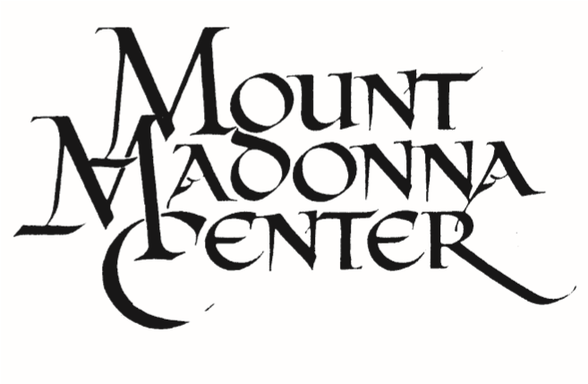
11
the Creative Arts & Sciences
445
Summit Road
•
Watsonville
•
,Ca 95076
408/847-0406
•
Www.MountMadonna.org
for

 | Breakfast | Lunch | Dinner
Monday | 8:15 – 9:15am | 12:30 – 1:30pm | 5:00 – 6:00 pm
Tuesday | 8:15 – 9:15am | 12:30 – 1:30pm | 5:00 – 6:00 pm
Wednesday | 8:15 – 9:15am | 12:30 – 1:30pm | 5:00 – 6:00 pm
Thursday | 8:15 – 9:15am | 12:30 – 1:30pm | 5:00 – 6:00 pm
Friday | 8:15 – 9:15am | 12:30 – 1:30pm | 5:30 – 6:30 pm
Saturday | Community Building closed 7:15-9:45am | 10:00 – 11:00am | 5:00 – 6:00 pm
Sunday | 8:30 – 9:30am | 12:30 – 1:30pm | 5:00 pm – 6:00 pm
Welcome! We’re glad you are visiting! Here is some information to help make your stay more comfortable and enjoyable. If you need further help, please ask the Reception Office or Program staff.

Yoga Classes
We invite you to attend at no extra charge. Classes meet in the Redwood Yoga Room (unless otherwise noted), across the road from the Community Building. The Yoga Room is available for any silent practice when classes are not scheduled.

Monday | 7:00 - 8:00 am  10:30am – 12:00 pm | Pranayama & Meditation  Asana (All Levels) | Teachers Rotate  Nick
Tuesday | 6:30 – 7:30 am  7:30 – 8:30 am  9:15 – 10:45am  7:30 – 9:00pm | Pranayama & Meditation  Asana (All Levels)  Yoga Sutra Class (CB MAIN)  Asana & Pranayama (All Levels) | Stephanie & Haley  Haley  Brian
Wednesday | 6:30 – 7:00 am  7:00 – 8:30 pm  11:00am – 12:30pm  7:30-8:45pm | Pranayama & Meditation  Asana (All levels)  Primary Series (Intermediate)  Asana (All Levels)1 | Jessica  Jessica  Shantam  Purnima
Thursday | 6:30 – 7:30 am  7:30 – 8:30 am  9:15 – 10:30am  7:30 – 8:30 pm | Pranayama & Meditation  Asana (All levels)  Bhagavad Gita Class (CB Main)  Gentle Asana | Stephanie & Haley  Stephanie  Kara
Friday | 6:30 – 7:00 am  7:00 – 8:30 am | Pranayama & Meditation  Asana (Intermediate) | Sinéad  Sinéad
Saturday | 7:30 – 9:45 am  Please come to entire class if you choose to attend. | Pranayama, Meditation, Theory & Asana  Introductory Yoga Class | Teachers Rotate

Hanuman Temple: Join us for daily Arati (celebration of light) 6:30am and 6:00pm.
11
IMPORTANT INFORMATION:
FIRE SAFETY: Do not light candles, incense, or flames anywhere. If you smoke, there is one area designated for smoking: it is outdoors near the Conference Center west entrance.
IN CASE OF EMERGENCY: dial 9911 from Center phones or 911 from pay phones. Our address is 445 Summit Road, Watsonville, Santa Cruz County, CA 95076.
To contact our Security Team dial 1866-662-1275
CHECK-OUT TIME: Please vacate your room by 1:00 pm so it can be made ready for the next guest. You are welcome to stay on the property longer if you wish. If you would like to stay for dinner, you would need to make a reservation and pay separately.
VALUABLES: Please keep valuables (wallet, cell phone, laptop) in the safe in your room, in your locked vehicle, or in a hall locker at the Conference Center. Mount Madonna Center is not responsible for your valuables if they are not locked up.
WATER CONSERVATION: Please limit showers to 3 minutes and otherwise eliminate unnecessary water use. Kindly report any water leaks to the Programs Office. FILTERED WATER is available in the dining room, and Conference Center tea bar. Tap water is okay to drink but DO NOT drink water from the green agricultural spigots.
MEDICAL SERVICES: First Aid kits are in every building. For other needs, contact Doctors on Duty in Watsonville 831-722-1444, rather than going to Center Staff.
FOOD: No food or drink may be brought to the Center. Please do NOT take food to room or tent – we’ve had serious critter problems. Special food needs? See Programs staff.
QUIET HOURS: 9:00 pm to Breakfast. Please avoid any noise which may disturb others.
MAINTENANCE: Notice maintenance needs? Tell the Programs Office.
LAUNDRY service is available once a week ($1.50/lb - minimum $15). The drop off location is the bin below the Community Building West Deck (stairs next to café). Laundry is picked up on Thursday at noon and delivered Friday or Saturday at 10am. Information available at Programs office.
LOST AND FOUND: If you discover you’ve left something, call 408-846-4065.
MAIL, FAX, PHONE and COMPUTERS: See Reception Office. Wireless Internet is available in Conference Center, Seminar House, and the cafe. Please do not watch or listen to streaming video or music at any time during your stay due to our limited bandwidth. Thank you for your consideration.
TICK-BORNE LYME DISEASE AT MMC: Recently we have had our first two verified cases of tick-borne Lyme Disease at MMC. Here are two of the most important facts: 1) ticks get on you very fast when you sit down on fallen logs, or on the ground, in the woods, and 2) checking yourself after being outside is key -- there is 0% transmission if the tick is removed within 24 hours.

RECREATION & LEISURE ACTIVITIES:
HIKING is excellent on trails shown on the trail map in this packet. Beware of poison oak! Hike with a buddy! See “Enjoy a Hike” brochure on credenza in CB lobby.
BODYWORK: Call Kaya Kalpa Wellness Center for appointment 408-847-3276 direct, or 408-483-6326 cell.
HOT TUB is located next to the Kaya Kalpa Wellness Center. Open 10 am—10 pm. Bathing suit required. Bring a towel. Outdoor showers available near the hot tub
STORES: Hours are posted outside the stores, and on bulletin board in CB Lobby.
- OCEANVIEW BOOKS AND GIFTS: also has tapes and CDs, meditation supplies, clothing,
jewelry, towels, flashlights, and toiletries.
- AYURVEDA HERB SHOP: Selling quality bulk herbs, herbal teas, massage and essential oils,
and more! Located next to the Kaya Kalpa Wellness Center.
- ANJANEYA’S WORLD CAFÉ: Serving coffee, cold drinks, ice cream, and light snacks. It’s located
right next to the bookstore, and is a WIRELESS HOT SPOT.

DO YOU WISH TO STAY AN EXTRA NIGHT OR ATTEND ANOTHER PROGRAM?
See the Programs Office by 4 pm the day before your scheduled departure for lodging options
and to make your reservation. We welcome comments and suggestions.

MAY YOUR STAY BE NOURISHING AND REWARDING

